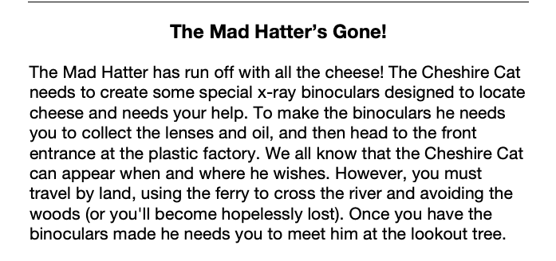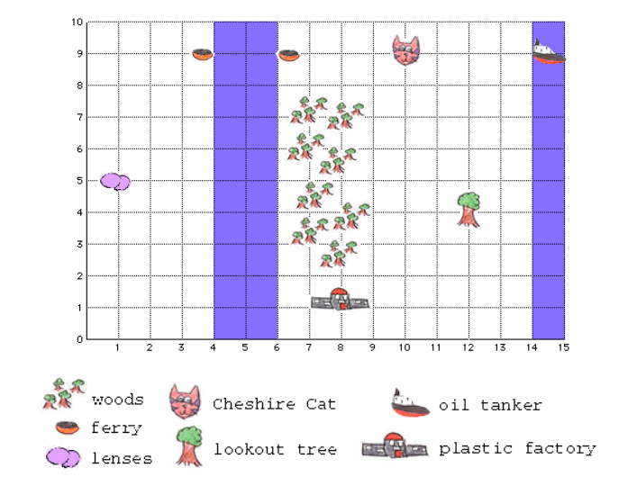

Directions: Write the coordinate for each item:

- Chesire Cat ( , ) 2. Lense ( , )

3. Oil tanker ( , ) 4. Front Entrance of Plastic Factory ( , )

5. Lookout Tree ( , )

Challenge: Can you find the shortest route to collect the materials, make the binoculars, and get to the lookout tree? Meet the Cheshire Cat on the map below and begin your planning. Your directions should include the whole number coordinates of each of the stops you make as well as the total distance you would travel.

