Addition Strategies
- Open Number Line

44 + 49 = 93
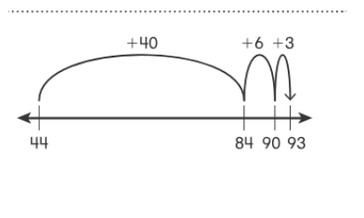
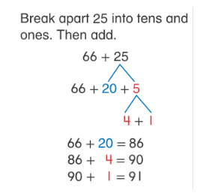
- Break Apart
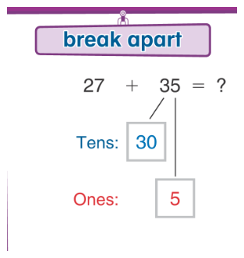
Step 1: 27 + 30 = 57
Step 2: 57 + 5 = 62

- Add with Partial Sums
  - Add the tens and write the partial sums.
  - Add the ones and write the partial sums.
  - Then add the partial sums to find the sum.
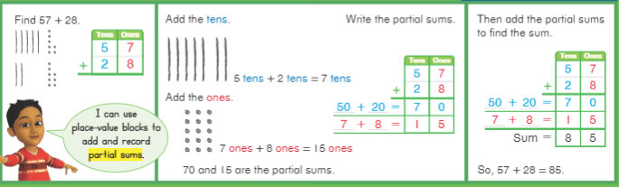
- Compensation

Adjust the addends by the same amount to create friendly numbers.

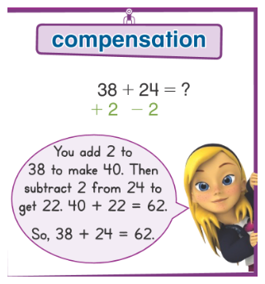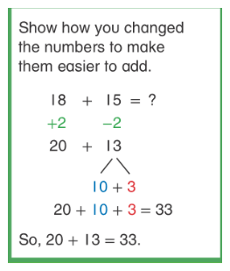

- Hundreds Chart

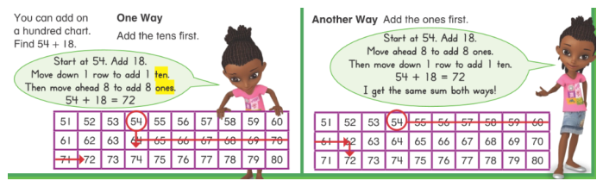
54 + 18 = 72.  Start at 54.  Move down 1 ten. Count on, to the right 8 ones. | 54 + 18 = 72.  Start at 54.  Count on, to the right 8 ones.  Move down 1 ten.

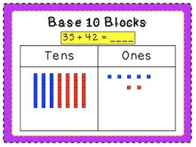
- Place Value Block

- Count out or draw the number of tens and ones you’ll need for each addend.
- Add the ones, regroup to form a ten if needed.
- Add the tens, including any you regrouped.

- Standard Algorithm *Note: This is not taught in our second-grade curriculum.
- Add the numbers in the ones place. Regroup if necessary.
- Add the numbers in the tens place. Include any number you regrouped.
1
54
+18
72

